**Project Planning Phase**

**Sprint Delivery plan**

**(Product Backlog, Sprint Planning, Stories, Story points)**

|  |  |
| --- | --- |
| Team ID | PNT2022TMID44772 |
| Project Name | Inventory Management System for  Retailers |

**Product Backlog, Sprint Schedule, and Estimation (4 Marks)**

Use the below template to create product backlog and sprint schedule

|  |  |  |  |  |  |  |
| --- | --- | --- | --- | --- | --- | --- |
| **Sprint** | **Functional**  **Requirement (Epic)** | **User Story Number** | **User Story / Task** | **Story Points** | **Priority** | **Team**  **Members** |
| Sprint-1 | Registration | USN-1 | As a user, I can register for the application by entering my email, password, and confirming my password. | 2 | High | 4 |
| Sprint-1 |  | USN-2 | As a user, I can register for the application through E-mail | 1 | Medium | 4 |
| Sprint-1 | Confirmation | USN-3 | As a user, I will receive confirmation email once I have registered for the application | 2 | Medium | 4 |

|  |  |  |  |  |  |  |
| --- | --- | --- | --- | --- | --- | --- |
| **Sprint** | **Functional**  **Requirement (Epic)** | **User Story Number** | **User Story / Task** | **Story Points** | **Priority** | **Team**  **Members** |
| Sprint-1 | Login | USN-4 | As a user, I can log into the application by entering email & password | 2 | High | 4 |
| Sprint-2 | Dashboard | USN-5 | As a user, I can view the products which are available | 4 | High | 4 |
| Sprint-2 | Add items to cart | USN-6 | As a user, I can add the products I wish to buy to the carts. | 5 | Medium | 4 |
| Sprint-3 | Stock Update | USN-7 | As a user, I can add products which are not available in the dashboard to the stock list. | 5 | Medium | 4 |
| Sprint-4 | Request to  Customer  Care | USN-8 | As a user, I can contact the  Customer Care Executive and request any services I want from the customer care. | 5 | Low | 4 |
| Sprint-4 | Contact  Administrator | USN-9 | I can be able to report any difficulties I experience as a report | 5 | Medium | 4 |

**Project Tracker, Velocity & Burndown Chart: (4 Marks)**

|  |  |  |  |  |  |  |
| --- | --- | --- | --- | --- | --- | --- |
| **Sprint** | **Total Story Points** | **Duration** | **Sprint Start Date** | **Sprint End Date (Planned)** | **Story Points Completed (as on Planned End Date)** | **Sprint Release Date (Actual)** |
| Sprint-1 | 7 | 6 Days | 27 Oct 2022 | 29 Oct 2022 | 7 | 29 Oct 2022 |
| Sprint-2 | 9 | 6 Days | 01 Nov 2022 | 05 Nov 2022 | 9 | 05 Nov 2022 |
| Sprint-3 | 5 | 6 Days | 07 Nov 2022 | 12 Nov 2022 | 5 | 12 Nov 2022 |
| Sprint-4 | 10 | 6 Days | 14 Nov 2022 | 19 Nov 2022 | 10 | 19 Nov 2022 |

**Velocity:**

|  |  |  |  |
| --- | --- | --- | --- |
| Sprints | Sprint Duration | Velocity | Actual Velocity |
| Sprint-1 | 6 | 7 | 0.85 |
| Sprint-2 | 6 | 9 | 0.66 |
| Sprint-3 | 6 | 5 | 1.2 |
| Sprint-4 | 6 | 10 | 0.6 |

**Burndown Chart:**

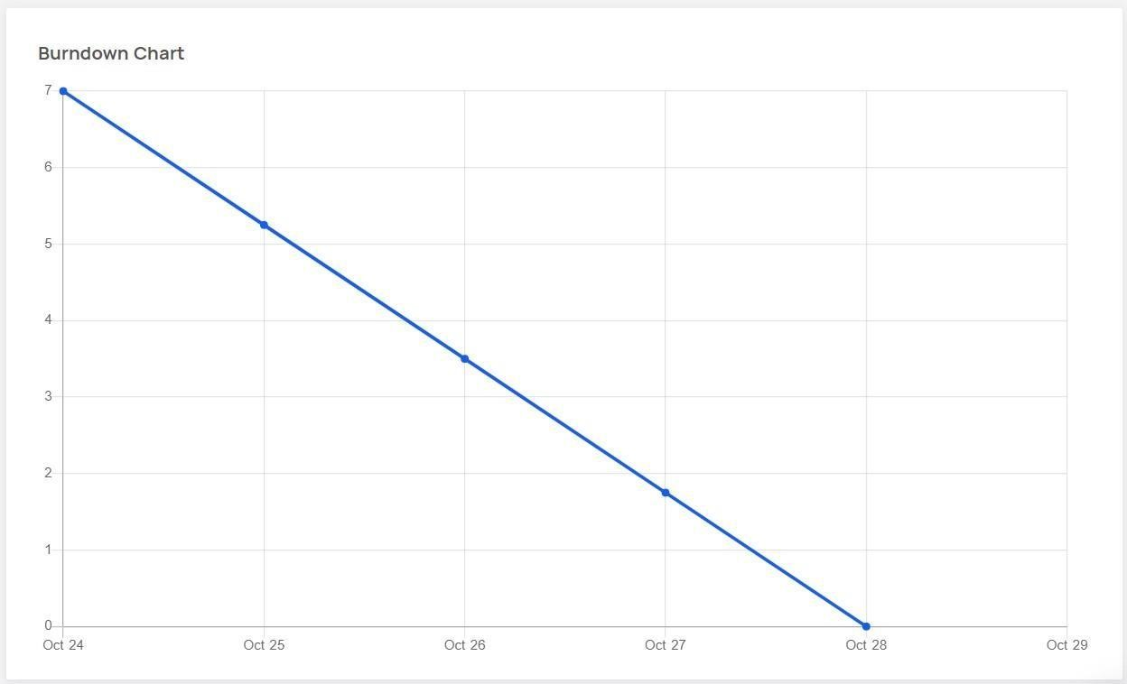

**Sprint - 1**

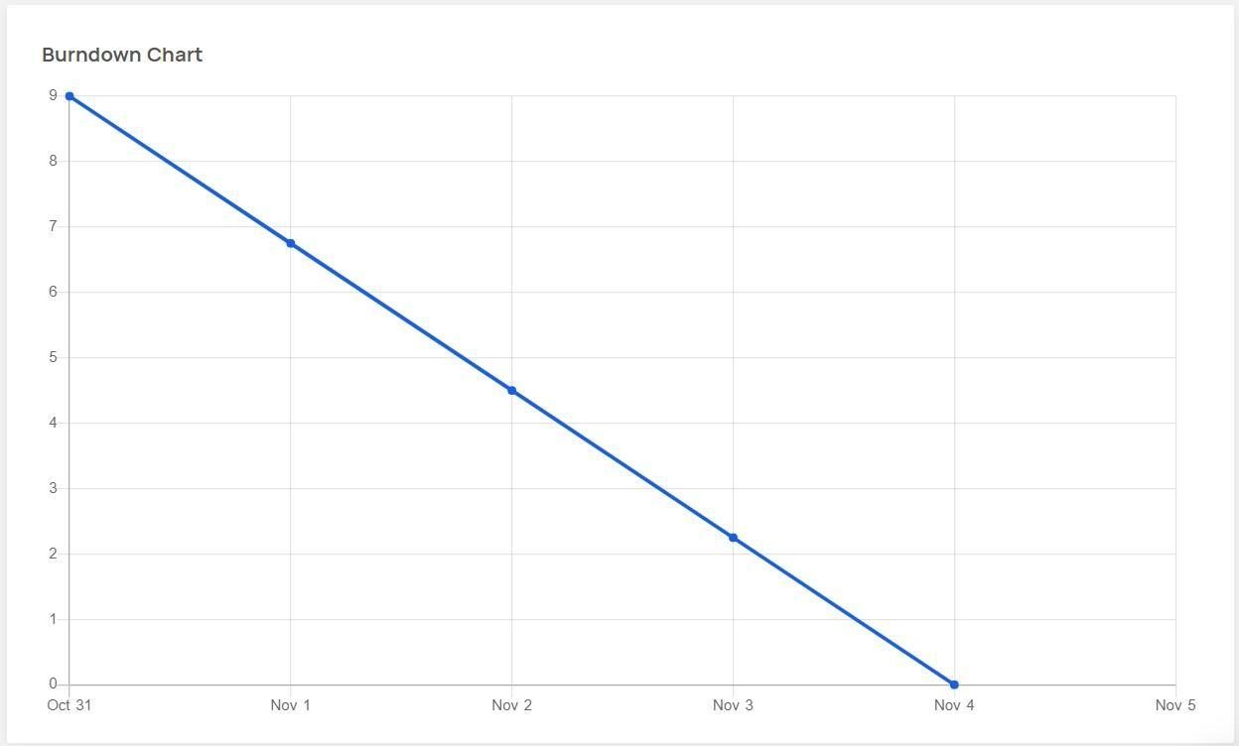

**Sprint – 2**

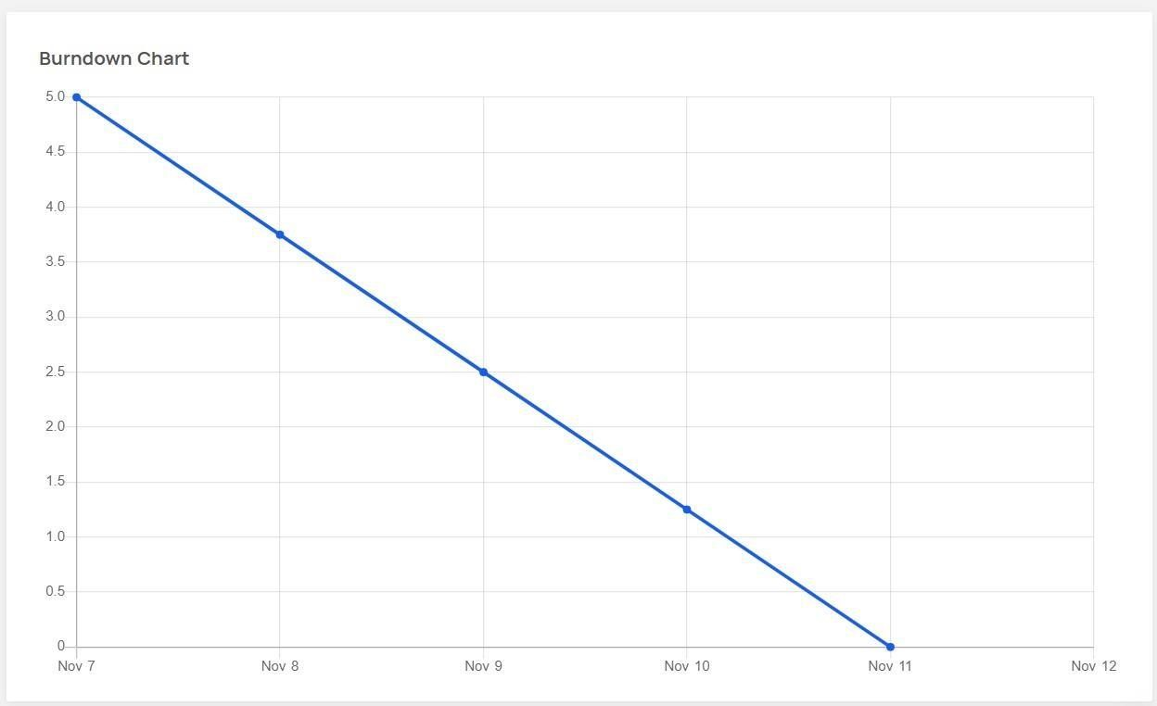

**Sprint - 3**

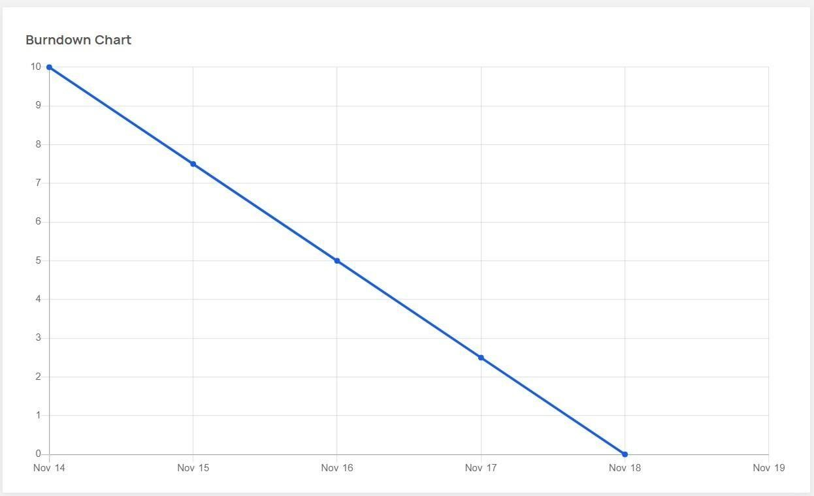

**Sprint – 4**